Supporting Visual Analytics Using Ontologies Across Heterogeneous Data
John Fallon, Jie Song, Nagasravika Bodapati, Lopamudra Pal, Kriti Shrivastava, Georges Grinstein
University of Massachusetts Amherst, Amherst MA 01003, USA
jtfallon|jsong|nbodapati|lpal|kshrivastava|ggrinstein@umass.edu
Abstract. Visual analytics is a process that can be greatly enriched with deeper data connections across heterogeneous data sources. In complex scenarios there are often many data streams all containing pieces of a puzzle for an analyst to solve. When the analysis is spread out across various tools having data linking issues or incompatibilities between the tools, the puzzle can take longer to solve and details may be overlooked. In this paper, we introduce a framework that uses ontologies to map both data between different sources as well as APIs between different software tools. This supports harnessing different libraries for their specific capabilities and thus provides visualizations that help explore deeply connected relationships within the heterogeneous data. We used the VAST Challenge contest data as use cases for our environment. We give examples of how our environment provided insight and data connections by being able to steer the visual analytics process towards a proper solution. Various visualization tools are presented ranging from summary visualizations to linked visualizations that drill down into detailed views. The goal of the system is to be extensible across many visualization and machine learning packages.
Keywords: Visual analytics, visualization, linked data, heterogeneous data, ontology.
- Introduction
With an increasing amount of data comes an increasing amount of data sources that are oftentimes connected to some extent, but are difficult to visualize and analyze in a joint fashion. There is a need for visualization systems that can seamlessly support visual analytics across datasets that are considered disparate due to data formatting issues and different data producers. Keim et al. have stated “Nearly all grand challenge problems of the 21st century, such as climate change, the energy crisis, the financial crisis, the health crisis and the security crisis, require the analysis of very large and complex datasets, which can be done neither by the computer nor the human alone” [1]. The goal of this research is to develop a web-based visualization environment to enhance sensemaking and situational awareness with heterogeneous datasets, feeding into the future work described by Keim et al. Driven by ontologies mapping entities across related datasets as a representation of the world and its state, our system enables drawing conclusions between related entities in each dataset and thus facilitates integrated visualization and visual analytics.
We present a system that can ingest data from varying text-based sources about a related incident or event and provide sensible visualizations and insight for visual analytics by using machine learning techniques to gain insight about the data. It’s well-known analysts may get lost when solving big data problems and that one strong aid is the use of intelligent machine learning algorithms [2]. Our framework handles text-based data and is being expanded to video and imagery data as described later. The system provides for the linking of diverse data collections for joint analysis helping an analyst discover deeper low level embedded links within the data.
- Related Work
There have been a number of systems that attempt to tie together heterogeneous data sources and provide visualization interfaces on top of the data. Most systems focus on providing interfaces to view portions of the data directly, while others perform some analytics and provide accompanying visualizations. This section will briefly look at systems in both of those classifications.
  - Linked Data with Visualization
Video Lens merges multiple heterogeneous data sources through the use of metadata and exposes a synchronized view [3]. It focuses on using timestamps from Major League Baseball (MLB) data to provide a unified view that includes video, game status, and transcripts. This system is supported with a small user study that concluded its querying capabilities were powerful enough to answer analytical questions. The system does not automatically apply any machine learning algorithms to the data. Video Lens nicely ties together heterogeneous data for overview purposes through metadata but may suffer from scalability issues due to a lack of analytics.
Mutlu et al. have developed a system using a common vocabulary to suggest visualizations for different forms of research data [4]. Forming links between data is closely related to what our work capitalizes on, however their system requires incoming data to adhere to a standardized set of key terms. Once the standards have been met, Mutlu et al.’s work is able to generate and suggest appropriate visualizations for the data. This work demonstrates early progress in the domain of visualization recommendation at a simple level.
Urban planning and development have made strides in incorporating linked data through platforms like QuerioCity [5]. QuerioCity had to manage working with high heterogeneity within the data alongside handling static and streaming data. The urban data that was the focus of the project wasn’t well standardized across sources, meaning there needed to be a high degree of flexibility. As data was ingested it was transformed into an RDF formatted ontology structure to support querying and linking with data from other sources. This model of creating an ontological structure to support understanding of new data sources is replicated in work done in our system. Their work allowed for frontend visualizations of the ingested data linked through the underlying ontological structure. The visualizations supported simple operations such as querying and aggregate functions.
  - Linked Data Supported By Analytics
Analytics of linked data has the potential to discover deep rooted links. conTEXT is a lightweight text analytics platform that focuses on incorporating such linked data [6]. The platform ingests any text corpus from the web – regardless of its structure. It then exposes NLP functionality, mostly Named Entity Recognition, and is supported by visualization. This system’s flexibility and analytical capabilities make it a good option for quick insightful overview analysis of a web-based text corpus.
Many domains now have an increased need to perform complex analysis across heterogeneous data sources. Streit et al. refined model-driven design for visual analysis in the biomedical domain [7]. Their work defines a workflow model that can then be implemented in user defined data transformations. They provide a Knowledge View, focusing on data visualization, and a Navigation View which focuses on data, views, analysis paths and the links between them. The strength of this work lies in modeling data ingestion from different sources, defining a proper workflow related to the incoming data, and supporting the analyst through various visualizations using the defined data transformations. This work is highly dependent on an expert in a given domain being able to help guide the modeling process for the related datasets.
- System Overview
The system currently focuses on ingesting and analyzing heterogeneous text corpora. Python has been selected as the primary development language due to having well defined machine learning and visualization ecosystems. We have selected Bokeh [8] as a visualization package for its ability to output web based visualizations that have full support for interactions such as selection and subsetting. With support for external tools, there are many supporting options to accompany our current package selections. The system performs various flexible NLP functions upon the data, including entity extraction, sentiment analysis, and co-occurrence identification. The system uses Radviz [9] as a primary analysis driver within the visualization environment. Radviz was chosen as a driver for the visual analytics process due to its ability to visualize very high-dimensional data. There has been much work using Radviz for high dimensional scalable visualizations and optimizing its usage therein [10][11][12][13]. It enables an analyst to quickly distinguish patterns or clusters within the data while viewing many dimensions interacting with one another. One use case supporting Radviz is discussed by Bello-Orgaz et al. with the need for identification of events, patterns, behaviors, and influencers in social networks [14].
Other classical visualizations are provided to support drilling down analysis such as bar charts, scatter plots, graphs, word clouds, and parallel coordinates. The Bokeh visualization package provides these while still allowing for customization where needed. Radviz was implemented as a custom visualization within the Bokeh framework.
The Bokeh library enables external communication through Javascript callbacks. The Javascript callbacks enable our system to communicate with other web-based tools external to our ecosystem. Our Bokeh based visualization system can serve as a driver of a more complex visualization system that is composed of other web based visualization packages all working in conjunction. Through standardized API calls exposed as Javascript callbacks, interactions between the locally developed visualizations and external visualizations can be controlled and synchronized. For example we linked parallel coordinates written in D3[15] and Cytoscape[16] with all our Bokeh visualizations using the described callback system. The web-based nature of the system enables an arbitrary number of simultaneous users.
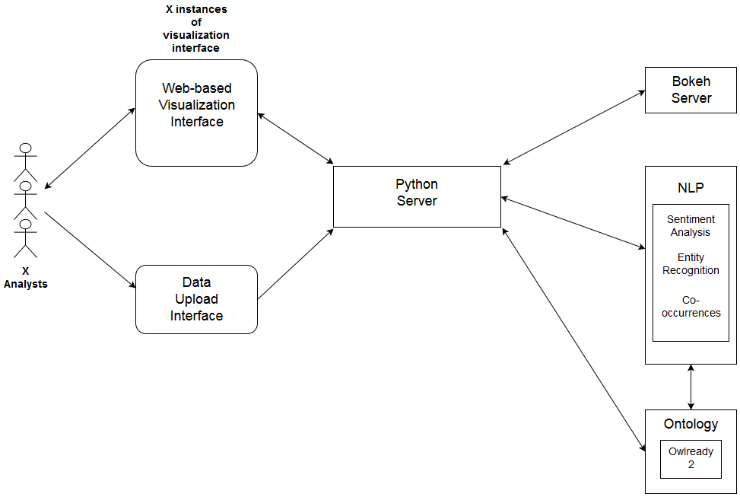
Figure 1. System architecture/workflow diagram.
An architecture/workflow hybrid diagram (Figure 1) presents a system overview. The typical workflow involves first uploading the text corpora for investigation and analysis. The text is processed for entities, sentiment surrounding the entities, and co-occurrences of entities in relation to 1) who, 2) where, and 3) when, and future: 4) what, 5) why and others. At this processing phase, the entities are also stored into an OWL-based ontology format using the Owlready 2 library [17]. This ontology represents the system’s understanding of the world and operates as a central knowledge store of the system. After all of these operations have been performed, the web-based visualizations are generated and viewed through a web browser. A fully interactive Radviz view colored by sentiment is the first view encountered. Anchor points (parameters or features) and data points (records inside Radviz) are selectable and filterable. Using one or more Radviz displays guide the analysis, selections and subsetting updates to other subsequent visualizations such as scatterplots that serve as timelines, graphs that show relationships between entities, and graphs showing the files in question and their relations to other files (refer to Figure 2).
Radviz plays a central role in enabling visualizations that can scale with many variables, over a million if required. The automatic machine learning based analytics aid in providing a head start for an analyst to quickly start following leads in their analysis. A major advantage of the system is its flexibility in dealing seamlessly with heterogeneous data sources within this visualization environment. Scalability and incorporating more data types are addressed in the Conclusion and Future Work section.
- System Application
Our system has been tested on heterogeneous data containing ground truth relating to a contained incident over a period of a few days. The data is sourced from the 2006 VAST Challenge [18]. The data contains over 1,000 news articles not standardized in format along with supplementary images and CSV based data. Our system ingested the data, linked data based on matching entities, and provided visualizations for analysis.
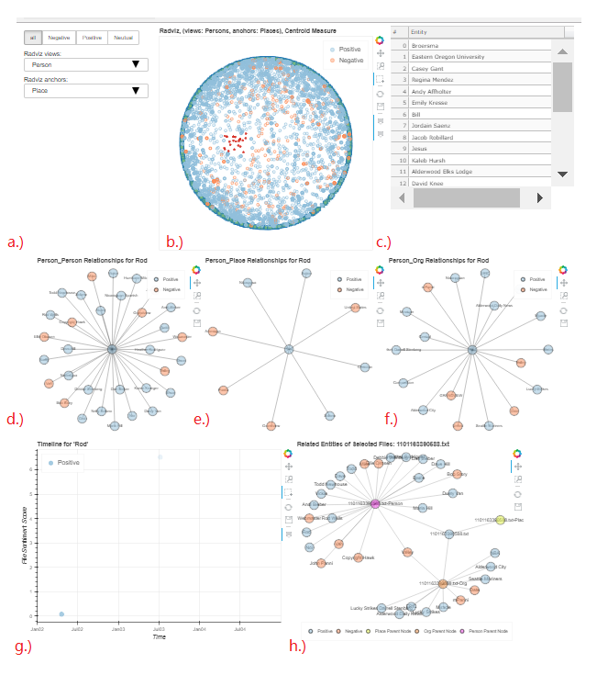
Figure 2. Exploratory dashboard for the VAST Challenge 2006. a) selection options for sentiment and Radviz; b) Radviz for entities; c) Data Table for selected records in Radviz; d) most related person for selected entities in the Data Table; e) most related place for selected entities in the Data Table; f) most related organizations for selected entities in the Data Table; g) timeline for selected entities in the Data Table; h) network graph for entities involved in selected file in Timeline plot.
Figure 2 displays a Radviz visualization as its central control view. It provides a high-dimensional view of the data where color is used to represent sentiment indicating strong positive or negative leads for our analysis. As selections and subsetting occur, all other visualizations are updated showcasing pertinent data based on the points of interest being inspected. Graph views are exposed that show the files containing certain entities enabling quick inspection of related source materials. The usability exposed by the system supports situational awareness by allowing the analyst full exploration and querying of all aspects of the project [19].
In conjunction with this primary view is a separate window managed by the system that provides linked D3 visualizations (see figure 3). The parallel coordinates and table focus specifically on organizations to facilitate identification of which may require further exploration.
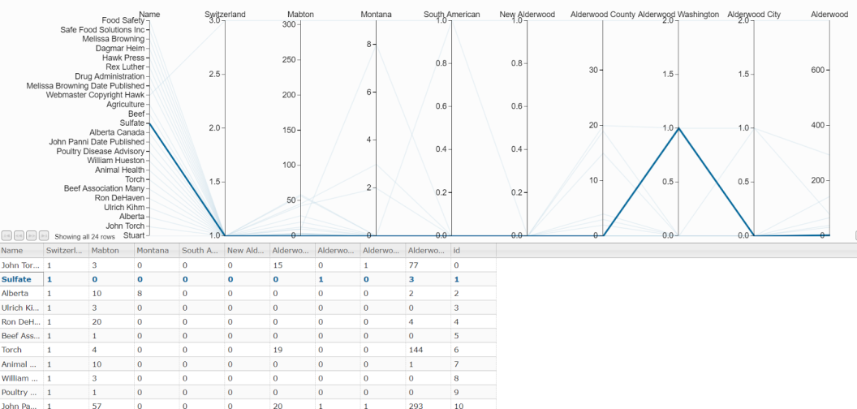
Figure 3. A D3 parallel-coordinate visualization showing the links between people and the places they have been to. It was auto-generated from co-occurrence analysis. The data has been filtered with “Switzerland” to identify individuals who went to Switzerland and are also related to the city Alderwood. The leftmost coordinate shows the individuals for which more negative sentiments were expressed in documents. The remaining coordinates showcase number of co-occurrences with a given location.
Using the Radviz and graph visualizations, we were able to rapidly zero in on those individuals likely involved in criminal activity. To work out details in their relationships (places, organizations, timing) we used parallel-coordinates (Figure 3). This led to a solution for who, where, when, what, and why when supported by inspecting the source material the system guided us to. In this case the when, where, and who were resolved by the analyst interacting with visualizations.
- Conclusion and Future Work
We have described a visual analytics system that incorporates machine learning and ontologies to ingest heterogeneous data and enable detailed insights that may otherwise have been missed in a high level data analysis. The system is written in Python and generates Javascript-based web pages with linked interactive visualizations that are customizable and support multiple interactions. The system has thus far been tuned for visualization of a scenario with multiple related datasets having a number of different ground truths. One valuable aspect of the system is its enabling of linking with other visualization systems through a standardized Javascript API, thereby not requiring the system to have all visualizations implemented.
The system thus far has been tested mostly on text-based data sources. Our next test is the addition of video-based data. Computer vision recognition algorithms will be applied to scenes in provided videos to deduce possible related entities, locations, and timeframes in which direct links to text-based data that has been ingested can be cemented. Caffe [20], a video analytics support library, will be used for analysis model support and the system will provide a video viewer as an additional visualization tool. This tool will be able to jump around different videos in the corpus and use key frames as indices in which to correlate identified entities that an analyst can quickly look at and analyze within the scope of the full dataset.
The concept of the machine learning algorithms being interchangeable is also being introduced. To change the machine learning algorithms currently being used requires code changes across multiple files and incorporating the correct libraries. We are developing a simple interface in which a user can easily plug in their own algorithm for various tasks or point to an already existing solution they would like to test in comparison to other algorithms. Visualizations will be provided that show differences in classification across different algorithms enabling the analyst to have finer control over which algorithm is appropriate to use for the given specific data and use cases. Multiple algorithms will be exposed through a selection interface for testing and incorporation into the pipeline, should the analyst decide to explore alternative options for tasks such as entity recognition and sentiment analysis.
The final focus of future work will be on scalability. Performing computations related to NLP, for example, in parallel would allow for horizontal scalability. There are a multitude of Python packages that will enable a transfer over to parallel computing that should enable much larger datasets to be ingested. The parallel computations aim to keep the majority of the computation strain on the server. This system aims to use the server as a central data store and computation center whereas the client aims to provide visualizations and guide the computations. This design model allows for easy enterprise level usage across many users.

References
- Keim, Daniel, and Leishi Zhang. "Solving problems with visual analytics: challenges and applications." Proceedings of the 11th International Conference on Knowledge Management and Knowledge Technologies. ACM, 2011.
- Jagadish, H. V., et al. "Big data and its technical challenges." Communications of the ACM 57.7 (2014): 86-94.
- Matejka, Justin, Tovi Grossman, and George Fitzmaurice. "Video lens: rapid playback and exploration of large video collections and associated metadata." Proceedings of the 27th annual ACM symposium on User interface software and technology. ACM, 2014.
- Mutlu, Belgin, et al. "Automated Visualization Support for Linked Research Data." I-SEMANTICS (Posters & Demos) 1026 (2013): 40-44.
- Lopez, Vanessa, et al. "Queriocity: A linked data platform for urban information management." International Semantic Web Conference. Springer, Berlin, Heidelberg, 2012.
- Khalili, Ali, Sören Auer, and Axel-Cyrille Ngonga Ngomo. "context–lightweight text analytics using linked data." European Semantic Web Conference. Springer, Cham, 2014.
- Streit, Marc, et al. "Model-driven design for the visual analysis of heterogeneous data." IEEE Transactions on Visualization and Computer Graphics 18.6 (2012): 998-1010.
- Bokeh Development Team (2014). Bokeh: Python library for interactive visualization
URL http://www.bokeh.pydata.org.
- Hoffman, Patrick, et al. "DNA visual and analytic data mining." Visualization'97., Proceedings. IEEE, 1997.
- Artero, Almir Olivette, Maria Cristina Ferreira de Oliveira, and Haim Levkowitz. "Enhanced high dimensional data visualization through dimension reduction and attribute arrangement." Information Visualization, 2006. IV 2006. Tenth International Conference on. IEEE, 2006.
- Grinstein, Georges, Marjan Trutschl, and Urška Cvek. "High-dimensional visualizations." Proceedings of the Visual Data Mining Workshop, KDD. 2001.
- Albuquerque, Georgia, et al. "Improving the visual analysis of high-dimensional datasets using quality measures." Visual Analytics Science and Technology (VAST), 2010 IEEE Symposium on. IEEE, 2010.
- Di Caro, Luigi, Vanessa Frias-Martinez, and Enrique Frias-Martinez. "Analyzing the role of dimension arrangement for data visualization in radviz." Advances in Knowledge Discovery and Data Mining (2010): 125-132.
- Bello-Orgaz, Gema, Jason J. Jung, and David Camacho. "Social big data: Recent achievements and new challenges." Information Fusion 28 (2016): 45-59.
- Bostock, Michael, Vadim Ogievetsky, and Jeffrey Heer. "D³ data-driven documents." IEEE transactions on visualization and computer graphics 17.12 (2011): 2301-2309.
- Shannon, Paul, et al. "Cytoscape: a software environment for integrated models of biomolecular interaction networks." Genome research 13.11 (2003): 2498-2504.
- Lamy, Jean-Baptiste. Owlready 2. 2014-2017. https://pypi.python.org/pypi/Owlready 2, last accessed 2017/07/21.
- Cook, Kristin, Georges Grinstein, and Mark Whiting. "The VAST Challenge: history, scope, and outcomes: An introduction to the Special Issue." (2014): 301-312.
- Endsley, Mica R. "Toward a theory of situation awareness in dynamic systems." Human Factors: The Journal of the Human Factors and Ergonomics Society 37.1 (1995): 32-64.
- Jia, Yangqing, et al. "Caffe: Convolutional architecture for fast feature embedding." Proceedings of the 22nd ACM international conference on Multimedia. ACM, 2014.

